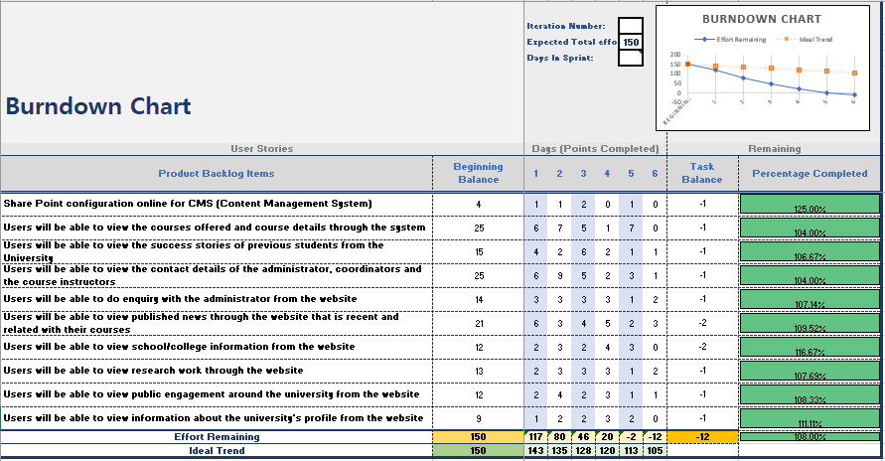

Figure 1: - Burndown Chart table

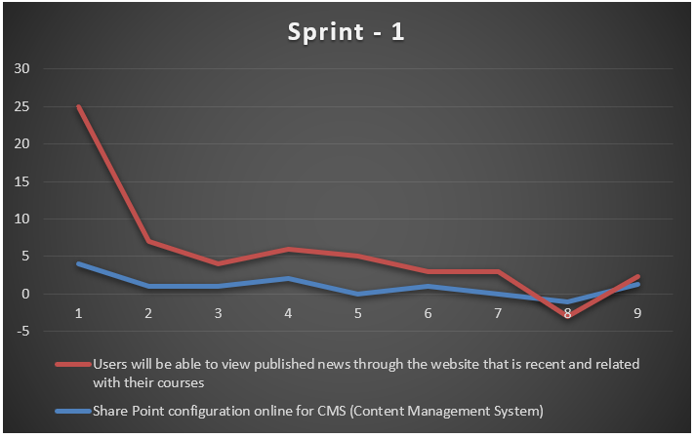

Figure 2: - Burndown Chart for Sprint -1

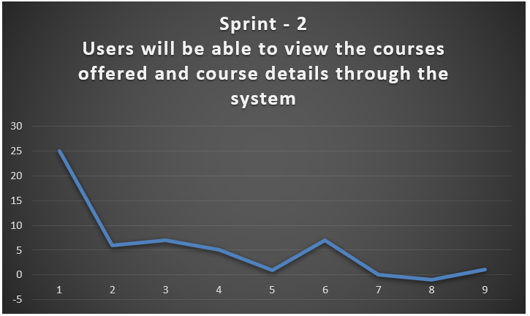

Figure 3: - Burndown Chart for Sprint -2

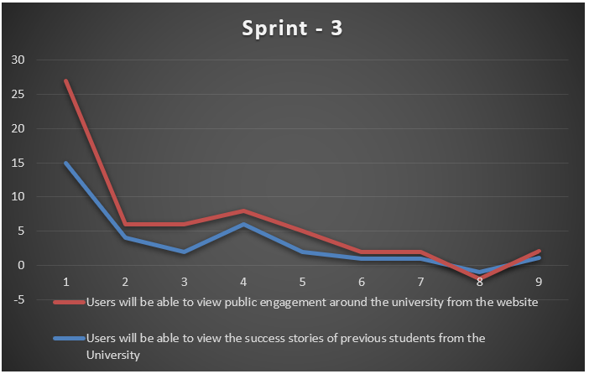

Figure 4: - Burndown Chart for Sprint -3

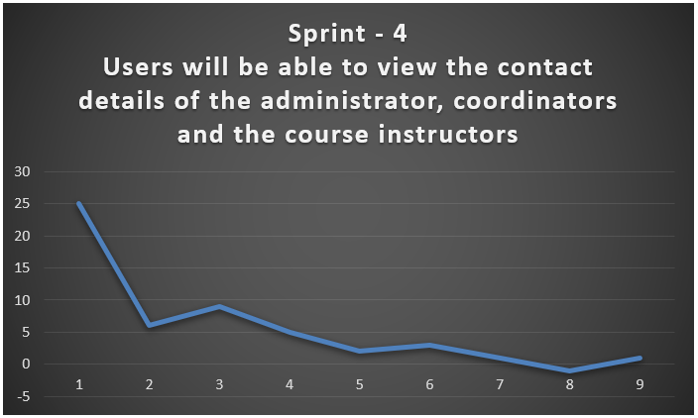

Figure 5: - Burndown Chart for Sprint -4

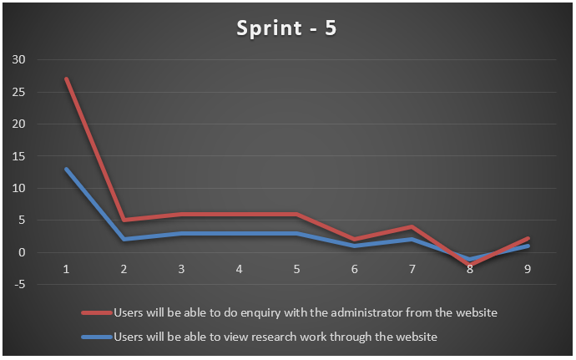

Figure 6: - Burndown Chart for Sprint -5

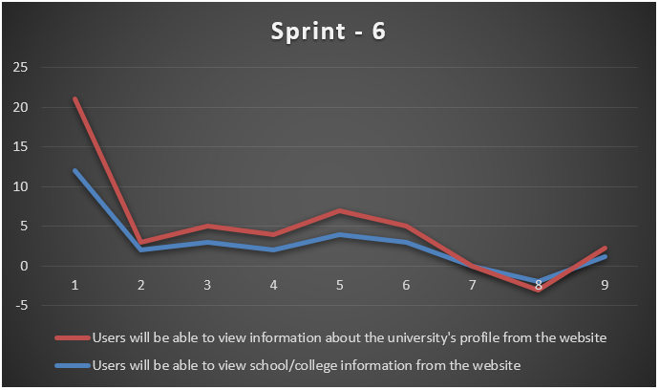

Figure 7: - Burndown Chart for Sprint -6

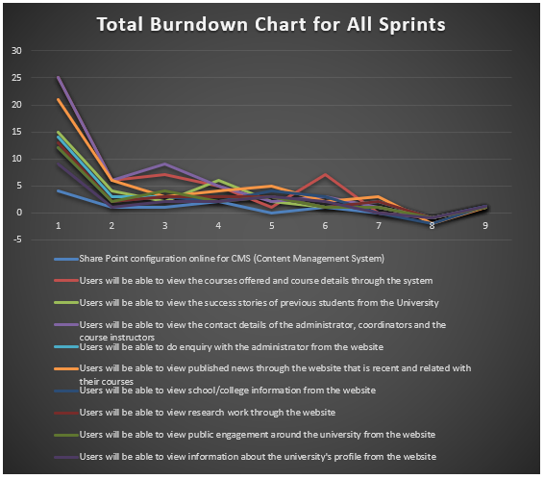

Figure 8: - Burndown Chart for All Sprint